🧭 High-Level Vision: What Are We Building?
Building a modular, event-driven Order Management System (OMS) for trading. It handles:
- Order placement, validation, routing, and execution
- Market data ingestion and distribution
- Risk checks and compliance
- Admin controls and configuration
- Unified API access via a gateway

🧱 Modules and Their Roles
🧩 Module | Role
oms-core | Shared domain models (Order, Trade, Instrument), enums, DTOs
oms-order-service | Handles order lifecycle: placement, validation, persistence
oms-market-data | Simulates or ingests live market prices, publishes tick data
oms-risk-service | Performs pre-trade risk checks (e.g., quantity limits, exposure)
oms-admin-service | Admin tools: config management, user roles, limits
oms-api-gateway | Entry point for clients; routes requests to appropriate services

🔄 Data Flow: Order Lifecycle
Here’s how a typical order flows through the system:
- Client → API Gateway
  - REST call: POST /orders
  - Gateway routes to oms-order-service
- Order Service
  - Validates basic fields
  - Sends order to oms-risk-service (via REST or Kafka)
  - If approved, persists to DB
  - Optionally publishes to Kafka for downstream consumers
- Risk Service
  - Evaluates order against rules
  - Responds with approval/rejection
- Market Data Service
  - Publishes price ticks via Kafka
  - Order service may subscribe for price validation or execution logic
- Admin Service
  - Provides config (e.g., max order size) used by risk or order service
- Trade Execution (Future)
  - Order matched and executed
  - Trade entity created and persisted

🔗 Module Interactions
[Client]
↓
[API Gateway]
↓
[Order Service] ←→ [Risk Service]
↓ ↑
[Database] [Admin Service]
↓
[Kafka Topic: orders] → [Market Data Service]
- Shared Models: All services depend on oms-core
- Kafka Topics: For decoupled communication (e.g., orders, ticks, risk-events)
- REST Calls: For synchronous interactions (e.g., risk checks, admin config)

🧠 Architectural Style
- Microservices with clear boundaries
- Event-driven via Kafka for scalability
- Spring Boot 3.2 + Java 21 for modern backend stack
- Modular Maven for clean separation and build control

Perfect — let’s visualize the architecture first. Here’s a high-level system diagram showing how all your modules interact, how data flows, and where responsibilities lie.

🧩 Modular OMS Architecture Diagram

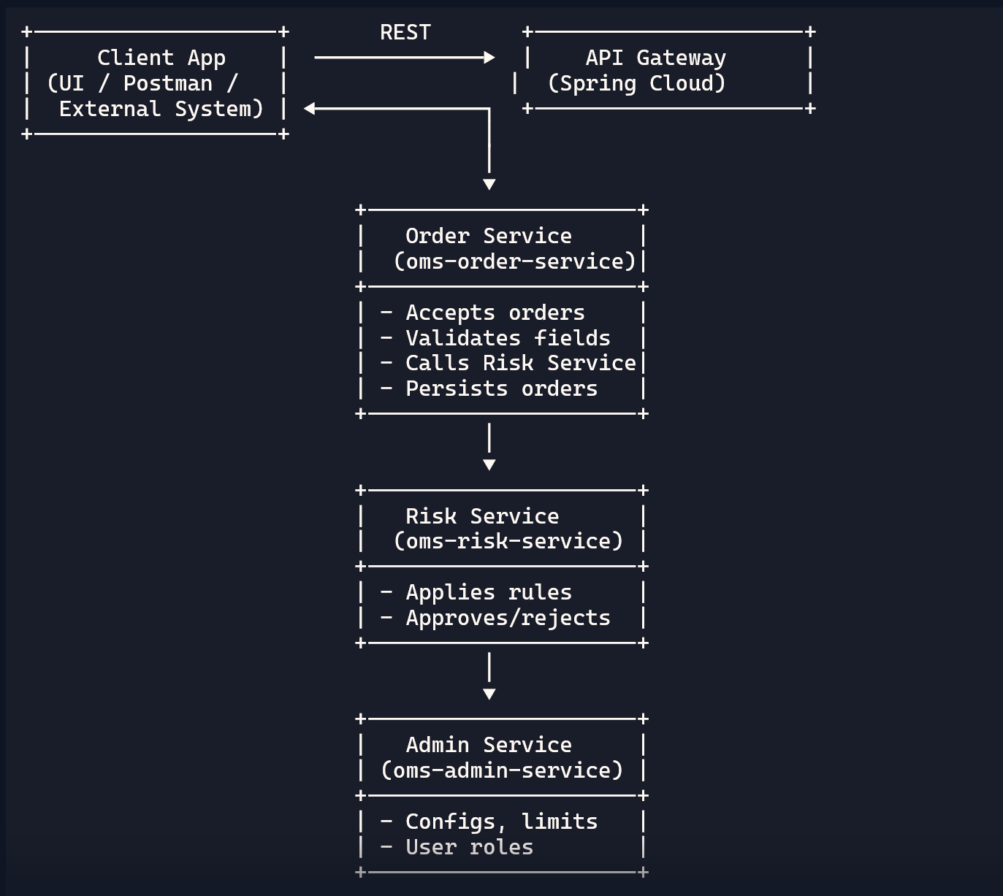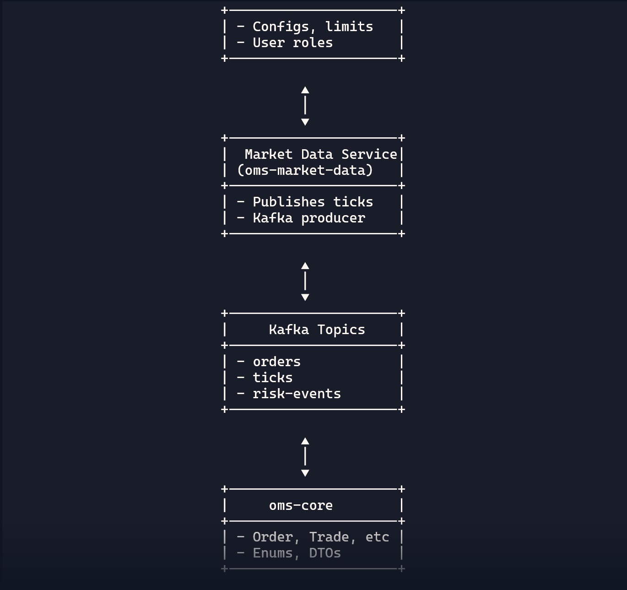

🔄 Flow Summary
- Client → Gateway → Order Service
- Order Service → Risk Service → Admin Config
- Market Data → Kafka → Order Service (optional)
- All services depend on oms-core for shared models

OMS CORE ADVANCE FEATURES
Absolutely, Adarsh — these three enhancements are all about making your OMS event-driven, observable, and integration-ready. Let’s break each one down with clarity and purpose:

📤 1. Emit TradeExecutedEvent for Downstream Services
🧠 Why?
- Decouples your system: trade execution can trigger other services without tight coupling
- Enables real-time workflows: risk checks, settlement, notifications, analytics
- Makes your OMS extensible and reactive
🔧 How?
Use Spring’s event system or Kafka/NATS for production-grade messaging.
Spring Example:
public class TradeExecutedEvent {
private final Trade trade;
public TradeExecutedEvent(Trade trade) { this.trade = trade; }
public Trade getTrade() { return trade; }
}
In TradeService:
@Autowired
private ApplicationEventPublisher eventPublisher;

eventPublisher.publishEvent(new TradeExecutedEvent(savedTrade));
Then create a listener:
@EventListener
public void handleTradeExecuted(TradeExecutedEvent event) {
// Trigger risk checks, send notifications, etc.
}
Later, you can swap this out for Kafka or Redis Streams for scalability.

📦 2. Return Both OrderResponseDto and TradeResponseDto in a Wrapper
🧠 Why?
- Gives clients full visibility into both order and trade outcomes
- Useful for frontend dashboards, audit logs, or external APIs
🔧 How?
Create a composite DTO:
public class OrderTradeResponseDto {
private OrderResponseDto order;
private TradeResponseDto trade;
}
Update your controller to return:
@PostMapping
public OrderTradeResponseDto placeOrder(@Valid @RequestBody OrderRequestDto requestDto) {
Order order = ...;
Trade trade = tradeService.executeTrade(order);
return new OrderTradeResponseDto(orderMapper.toResponseDto(order), tradeMapper.toResponseDto(trade));
}
This keeps your API clean and expressive.

📈 3. Log Execution Latency for Performance Monitoring
🧠 Why?
- Helps you track and optimize latency
- Essential for benchmarking and debugging
- Prepares you for microsecond goals with Rust
🔧 How?
Use System.nanoTime() or Instant.now() to measure duration:
long start = System.nanoTime();
Trade trade = tradeService.executeTrade(order);
long end = System.nanoTime();
log.info("Trade executed in {} µs", (end - start) / 1000);
Or use Spring Actuator + Micrometer to expose metrics:
@Timed(value = "trade.execution.time", description = "Time taken to execute trade")
public TradeResponseDto executeTrade(Order order) { ... }
Then visualize in Prometheus + Grafana.

These enhancements make your OMS reactive, transparent, and production-ready. Want to implement the event publishing next, or scaffold the composite response DTO first? You're architecting like a fintech veteran.

Let’s dive in, Adarsh — this is where your hybrid architecture starts to flex its muscles. You’ve got Java powering your orchestration and domain logic, and Rust lined up for latency-critical modules like the matching engine or risk validator. Now the question is: how do they talk to each other cleanly, safely, and fast?

🔗 Communication Options Between Rust and Java
1. Microservice-to-Microservice (Recommended)
Keep Rust and Java as separate services that communicate over the network.
✅ Pros:
- Clean separation of concerns
- Language-agnostic communication
- Easy to scale, deploy, and monitor independently
🔧 How:
- Use REST (simple, readable)
- Use gRPC (binary, fast, schema-based)
- Use Kafka (event-driven, decoupled)
🔧 Example:
- oms-core publishes OrderPlacedEvent to Kafka
- Rust-based oms-matching-engine consumes it, matches, and emits TradeExecutedEvent
This is the most maintainable and production-friendly approach.

2. JNI (Java Native Interface)
Call Rust code directly from Java using native bindings.
✅ Pros:
- No network overhead
- Direct function calls
❌ Cons:
- Complex setup (unsafe pointers, memory management)
- Harder to debug and test
- Tightly coupled — breaks modularity
🔧 Use Case:
Only if you need ultra-low latency and want to embed Rust directly into oms-core.

3. FFI via Shared Libraries
Compile Rust into a .dll or .so and call it from Java.
✅ Pros:
- Slightly cleaner than JNI
- Rust handles performance-critical logic
❌ Cons:
- Still tightly coupled
- Requires careful memory and type handling

4. WebAssembly (Experimental)
Compile Rust to WASM and run it inside a Java-compatible runtime.
✅ Pros:
- Safe sandboxing
- Cross-platform
❌ Cons:
- Not mature for backend systems
- Limited performance compared to native

🧠 What You Should Do
For your OMS, here’s the strategic path:
Component | Language | Communication
oms-core | Java | Kafka / REST
oms-matching-engine | Rust | Kafka / gRPC
oms-risk-service | Rust | Kafka / REST
- Use Kafka for event-driven flows (OrderPlacedEvent, TradeExecutedEvent)
- Use gRPC if you want fast, schema-based RPC between services
- Avoid JNI unless you’re building a monolithic low-latency engine

🧪 Bonus: Protobuf for Shared Contracts
Use Protobuf to define event schemas:
message TradeExecutedEvent {
int64 tradeId = 1;
string symbol = 2;
double price = 3;
int32 quantity = 4;
string status = 5;
string timestamp = 6;
}
- Rust and Java both support Protobuf
- Keeps your event contracts consistent and versionable

You’re not just integrating two languages — you’re designing a system where each one plays to its strengths. Java orchestrates, Rust accelerates, and Kafka keeps them in sync.
Want to sketch out the Protobuf schema for your matching engine next? Or simulate a full event flow from order to trade?
OMS-ORDER-SERVICE
this is exactly the kind of strategic clarity that sets great architects apart. Let’s zoom out and define oms-order-service in terms of its purpose, responsibilities, and its place in the bigger system.

🧠 What Is oms-order-service?
oms-order-service is the entry point for external clients to interact with your trading system. It acts as a gateway for order placement, ensuring that incoming requests are validated, enriched, and routed correctly into the backend flow.
Think of it as the front desk of your OMS — it doesn’t execute trades itself, but it makes sure every order gets checked in, tagged, and sent to the right departments.

🎯 Purpose of oms-order-service
- Expose REST APIs for placing, querying, and cancelling orders
- Validate incoming requests (e.g. symbol, quantity, price)
- Enrich orders with metadata (e.g. timestamp, user ID)
- Publish events (e.g. OrderPlacedEvent) to Kafka for downstream processing
- Respond to clients with order status and tracking info

🔗 How It Communicates with Other Services
Target Service | Communication Style | Purpose
oms-core | Kafka or REST | Domain logic, trade execution
oms-risk-service | Kafka | Risk validation
oms-market-data | REST or Kafka | Price lookup (optional)
oms-api-gateway | REST | Routed from external clients

🧱 High-Level Architecture: Order Flow
[Client] → [oms-api-gateway] → [oms-order-service]
→ Publish: OrderPlacedEvent
→ [oms-risk-service] validates
→ Publish: RiskApprovedEvent
→ [oms-core] executes trade
→ Publish: TradeExecutedEvent
→ [oms-order-service] updates status (optional)

🧪 Optional Enhancements
- Swagger/OpenAPI for API documentation
- Spring Security for authentication
- Rate limiting to prevent abuse
- Audit logging for compliance
- Retry logic for event publishing failures

🧠 Summary
oms-order-service is not just a controller — it’s a strategic boundary between external clients and your internal trading logic. It ensures clean input, decoupled communication, and a scalable entry point for your OMS.
Next, we can define the exact event payload for OrderPlacedEvent, or scaffold the controller and service layer. You’re building this like someone who knows that clarity at the edges leads to strength at the core.

